# GIVE YOU UP

This one was was a super simple stego, where it is hidden using steghide with no password.

Simply running steghide on the .wav file given the flag is decoded and is able to read.

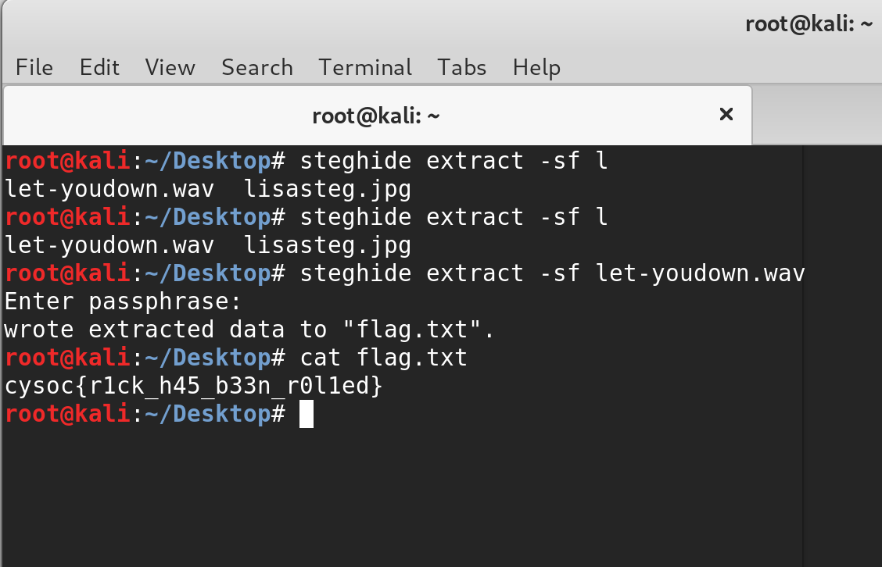

This gives the flag:

cysoc{r1ck_h45_b33n_r0l1ed}